**SMART HOME AUTOMATION USING TINKERCAD**

**CIRCUIT DESIGN:**

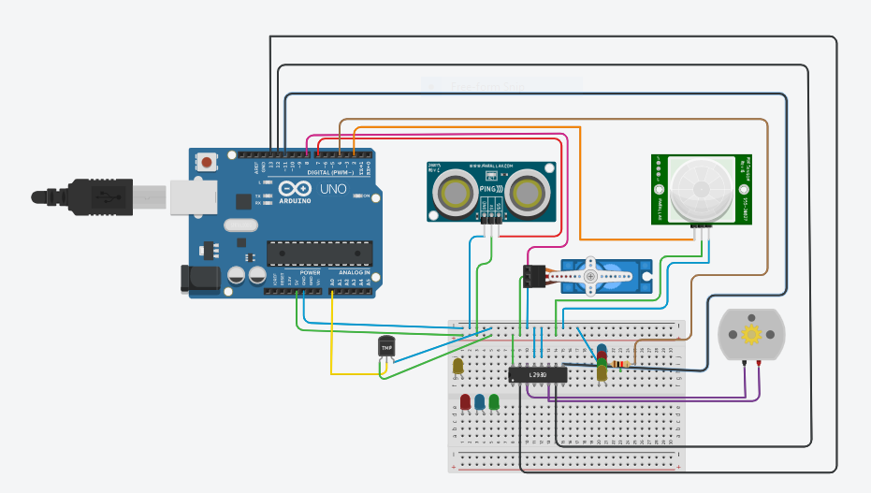

**CIRCUIT CODE:**

**#include<Servo.h>**

**const int pingPin = 7;**

**int servoPin = 8;**

**Servo servo1;**

**void setup() {**

**// initialize serial communication:**

**Serial.begin(9600);**

**servo1.attach(servoPin);**

**pinMode(2,INPUT);**

**pinMode(4,OUTPUT);**

**pinMode(11,OUTPUT);**

**pinMode(12,OUTPUT);**

**pinMode(13,OUTPUT);**

**pinMode(A0,INPUT);**

**digitalWrite(2,LOW);**

**digitalWrite(11,HIGH);**

**}**

**void loop() {**

**long duration, inches, cm;**

**pinMode(pingPin, OUTPUT);**

**digitalWrite(pingPin, LOW);**

**delayMicroseconds(2);**

**digitalWrite(pingPin, HIGH);**

**delayMicroseconds(5);**

**digitalWrite(pingPin, LOW);**

**// The same pin is used to read the signal from the PING))): a HIGH pulse**

**// whose duration is the time (in microseconds) from the sending of the ping**

**// to the reception of its echo off of an object.**

**pinMode(pingPin, INPUT);**

**duration = pulseIn(pingPin, HIGH);**

**// convert the time into a distance**

**inches = microsecondsToInches(duration);**

**cm = microsecondsToCentimeters(duration);**

**//Serial.print(inches);**

**//Serial.print("in, ");**

**//Serial.print(cm);**

**//Serial.print("cm");**

**//Serial.println();**

**//delay(100);**

**servo1.write(0);**

**if(cm < 40)**

**{**

**servo1.write(90);**

**delay(2000);**

**}**

**else**

**{**

**servo1.write(0);**

**}**

**// PIR with LED starts**

**int pir = digitalRead(2);**

**if(pir == HIGH)**

**{**

**digitalWrite(4,HIGH);**

**delay(1000);**

**}**

**else if(pir == LOW)**

**{**

**digitalWrite(4,LOW);**

**}**

**//temp with fan**

**float value=analogRead(A0);**

**float temperature=value*0.48;**

**Serial.println("temperature");**

**Serial.println(temperature);**

**if(temperature > 20)**

**{**

**digitalWrite(12,HIGH);**

**digitalWrite(13,LOW);**

**}**

**else**

**{**

**digitalWrite(12,LOW);**

**digitalWrite(13,LOW);**

**}**

**}**

**long microsecondsToInches(long microseconds) {**

**return microseconds / 74 / 2;**

**}**

**long microsecondsToCentimeters(long microseconds) {**

**return microseconds / 29 / 2;**

**}**

**CIRCUIT OUTPUT:**

